Using Miralax for your child’s constipation
Miralax is a very good stool softener for children ages 6 months and up. It works by bringing more water into the colon, softening the stool and making it easier to pass. It is very safe and is not habit forming.
Sometimes families say Miralax “doesn’t work.” This is usually because the child wasn’t on the right dose or didn’t take it for long enough. Sometimes it takes several days to figure out the right dose of Miralax for any given child. The good news is its nearly impossible to overdose on Miralax, and it’s usually possible to adjust a child’s dose at home.
The “right” dose of Miralax caries from child to child, depending on:
- Their age and size
- How constipated they are
- How often they are taking Miralax (every day for prevention, or just occasionally “as needed”)
- Their diet
- How much water and other fluids they take in
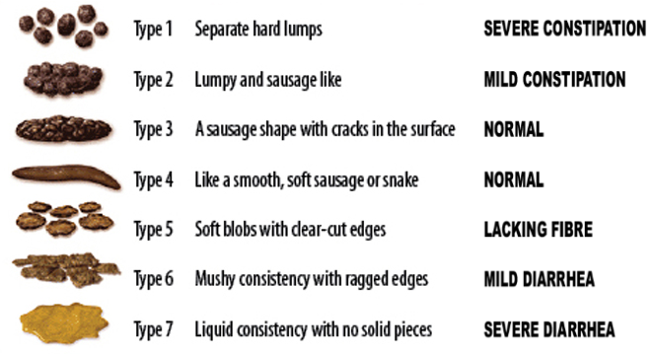
The goal of constipation treatment is to have a very soft bowel movement once a day. The consistency of the BM should be like soft-serve ice cream or applesauce (“Type 5” or “Type 6” in the chart.)

Here are good starting doses for kids:
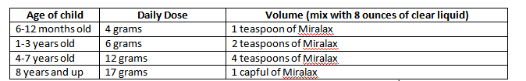
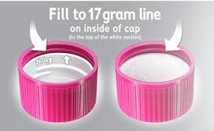
**One capful is equal to the top of the white insert inside the cap**
Take this dose for three days. On the third day, adjust the dose as follows:
- If your child’s most recent bowel movement is still type 1, 2, or 3, double the daily dose.
- If your child’s most recent bowel movement is entirely liquid (type 7), cut the daily dose in half.
- If your child’s most recent bowel movements is soft (type 4, 5, or 6), continue the same daily dose.
If you have adjusted the dose on the third day, wait three more days to see the effect of the new dose.

